
USER MANUAL
A guide to Chullu properties platform

December 1, 2025

www.chulluproperties.com

Contents
INTRODUCTION 2
What Chullu Properties offers; 3
Key Benefits to the Users 3
Section A: User Manual for Landlords/Agents 4
Section B: User Manual for Developers and Property Sellers 10
Section C: User Manual for Tenants/Buyers 11
Section D: Compliance and Disclaimer 13
Acceptance of Terms 14

INTRODUCTION

Dear Valued User,
Welcome to Chullu Properties, The Number 1 property management and rental marketplace platform
designed to simplify how landlords, property managers, agents, tenants, and buyers interact in the real
estate ecosystem.
Chullu Properties is built to eliminate inefficiencies associated with manual property management
processes. By combining automation, transparency, secure record-keeping, and seamless communication, the platform empowers users to manage properties, tenants, payments, and documentation from one central system—anytime, anywhere.
Whether you are a landlord seeking better control of your rental portfolio, an agent managing multiple
listings, or a tenant looking for a secure and transparent renting experience, Chullu Properties offers the
tools you need to operate efficiently and confidently.
This user manual provides step-by-step guidance on how to navigate the platform, utilize its features, and maximize the benefits available to you.

We are delighted to have you on board.

Warm regards,
The Chullu Properties Team

What Chullu Properties offers;

Key System Features;
- Secure user registration and Verification (KYC)
- Property listing for rent and sale
- Tenant onboarding and management
- Digital lease creation and acceptance
- Automated invoicing and rent collection
- Multiple payment options (Mobile money, Pesalink, Cards)
- Payment Tracking and Transaction history
- Maintenance and communication management
- Property requests and site visit scheduling
- Centralized document and record storage

Key Benefits to the Users;
For landlords, sellers and agent;
- reduced rent collection delays through automation
- Centralized management of multiple properties
- Transparent payment records and audit trails
- Improved tenant communication and accountability
- Reduced fraud through ownership verification
For Tenants and Buyers;
- Easy property search and comparison
- Secure lease agreements and payment records
- Transparent communication with landlords
- Digital access to invoices, receipts and agreements.

Section A: User Manual for Landlords/Agents

To register as a landlord;
- Registration process

To register as a landlord, property owner or agent;
- visit the Chullu properties platform and click sign up
-create your account by filling in the required details
-Proceed to complete the Know Your Customer (KYC) verification process

- Know your Customer Requirements

You will be required to fill in KYC requirements on the platform
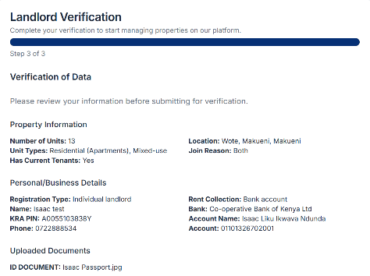
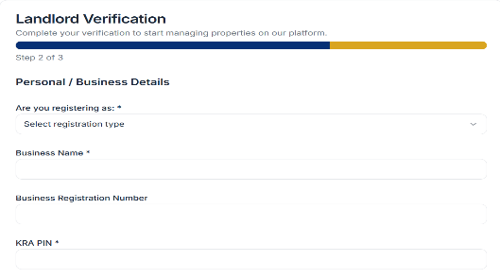
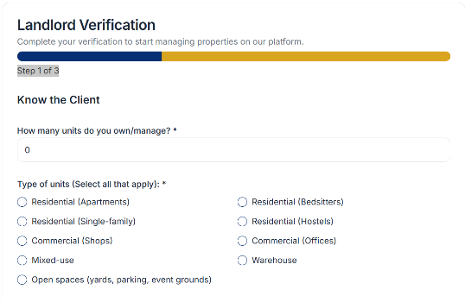

To complete this process, you will require the following documents and information;
For Limited companies;
- Certificate of incorporation/Business registration certificates
- Company KRA Pin Certificate
- Cancelled cheque or bank confirmation letter
- Company CR-12
- Property details
- Bank account details
- Official contact details
For individual Landlords;
- National ID or Passport
- KRA Pin Certificate
- Properties Details
- Bank account details
- Contact details

For Business Partnership;
- Partnership registration documents
- ID copies of Partners
- KRA Pin of partners
- Details of your properties
- Bank account details
- Contact details

For Agent/ Property Managers;
- Business Registration
- Valid Trading License
- KRA Pin Certificate
- Managed property details
- Bank account details
- Contact details

- Application review and approval;

Once you submit your application;
- The Chullu properties team will review your documents
- You will receive approval confirmation or feedback if corrections are required.
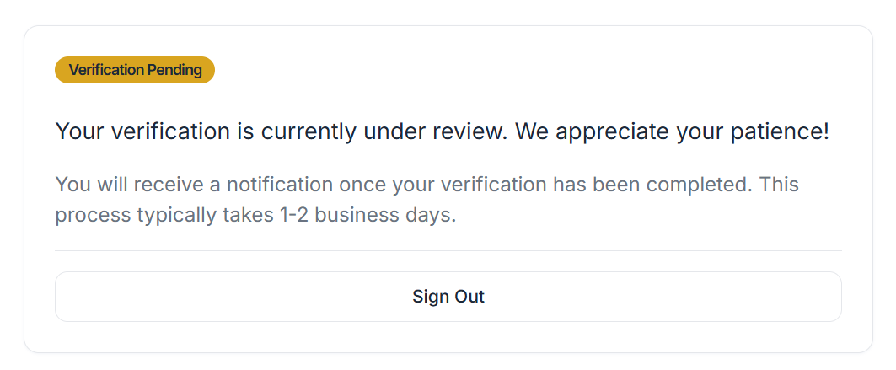

- Adding Properties;

After approval;
- Navigate to Add Property from your dashboard
- Enter property details for rent or sale
- Upload relevant images and description.
Vacant properties can be advertised immediately. Approved listing will be promoted across Chullu Properties’ social media channels.
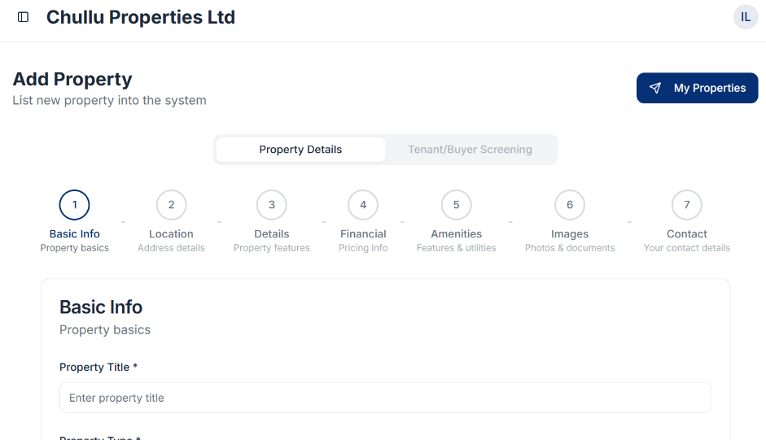

To prevent fraud and misrepresentation, Chullu Properties team requires all users to provide proof of ownership or legal authority for any property listed on the platform. Acceptable documentations include;
- A valid property title deed bearing your name or that of the registered company managing the property.
- A duly executed property management agreement granting you consent from the property owner to list and manage the property on the Chullu platform.
- Power of attorney issued by a qualified advocate of the High Court of Kenya, authorizing you to act on behalf of the property owner.

- Property approval by Chullu properties team;
Once your property has been approved by the Chullu properties team, you can;
- Advertise for vacant units of your property
- Add existing tenant to be managed from the platform

To Advertise vacant units;

- Fill in property details as guided in the site
- Configure the tenant screening questions(Optional). Mark mandatory questions where required
- Publish the listing
To add exist in tenants;

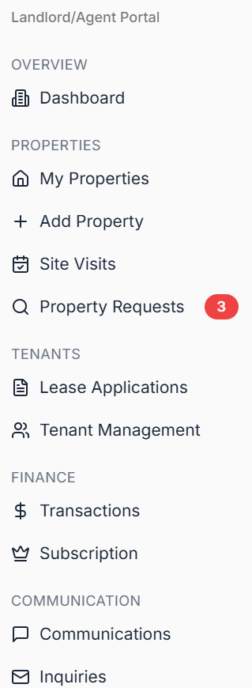
- Select Tenant management from the Landlord dashboard menu

- Add tenant details and submit;
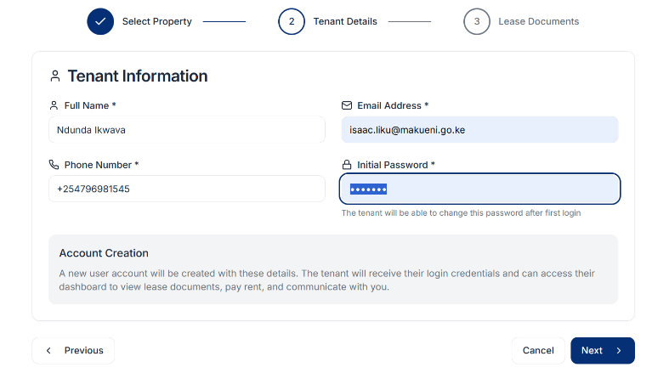

- Once submitted, the tenant will receive a notification informing them that they have been successfully on boarded on the platform and can log in to access their account.
- Responding to Site visits.

When a potential tenant requests a site visit;
- A notification appears in your dashboard
- You may respond via phone call or in-platform messaging

- Handling Property Request

Tenants unable to find suitable listing will submit property request. These request are visible to all the property agents and landlords. Matching property owners may respond directly to the request. The validity of the request is 30 days.

- Lease Application
Once a tenant applies for a lease, the landlord may;
- Draft a lease agreement within the platform; or
- Upload an externally prepared lease.
- Tenant accept the lease digitally. Acceptance is legally binding and recorded in the system.
- Upon acceptance, Landlords generate invoices covering rent and security deposit.

- Invoicing Tenants;

While setting up the tenant account,
- Set rent payment schedules
- Issue additional invoices for utilities or extra charges
- Tenants will receive instant notification when bills are due

- Tracking Payments

Once invoices are paid the landlord will;
- Get an SMS notification informing of the invoice payment.
- Track the payments on the Dash board
- Payments made from the system invoice will reflect in the landlords account within 48Hrs after payment. All payments are settled automatically.

- Handling Communications

- Tenants are able to send maintenance communication via the system.
- All communications are recorded for reference and accountability.

Section B: User Manual for Developers and Property Sellers

- Developer/seller on boarding
Property developers or sellers seeking to list properties on the platform must contact Chullu properties and provide the required information for onboarding and verification
The onboarding process shall include submission of the following documents
a) For individual’s sellers;
-National ID
-KRA Pin certificate
-Contact Details
For Corporate Sellers;
-Certificate of incorporation
-Company KRA PIN
-Authorized Contact Details
- Property ownership Verification
– Proof of ownership or legal requirements to sell the property.
- Property Details
-Property Location
Property description and specifications
Selling price
- Authorization to sell
An authorization letter drafted by an Advocate of the High Court of Kenya granting Chullu Properties consent to list and facilitate the sale of the property on the platform
- Site Visit and Access Authorization
- Approval for Chullu Properties to coordinate site visits with prospective buyers
Once all submitted information has been verified and approved, Chullu Properties will publish the property listing on the platform.

Section C: User Manual for Tenants/Buyers
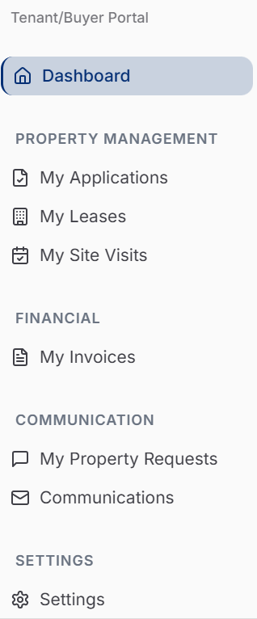
As a tenant or prospective property buyer, the Chullu platform provides a seamless way to search for and identify your ideal property for rent or purchase, while securely maintaining digital records that create a transparent trail of every step taken throughout the property acquisition process.

- Registration.

Tenants and buyers must create a free account to access all features.

- Property Search.

- Browse available rental and sale listings
- Book site visits or contact landlords directly
If no suitable property is found, submit a Property Request outlining your requirements.
- Lease application.

After Viewing a property;
- Apply for a lease through the system
- Complete screening questions where applicable
- Review and accept lease terms digitally
Accepted lease is legally binding and securely stored on the platform.

- Making Payments.

Upon acceptance, you will proceed to make payments of the invoice.

- Pay invoices electronically via mobile money, Pesalink or Card
- View payment records in your ledger

Recurring rent invoices are issued automatically based on the landlord setting

- Communications.
The tenant can;
- Submit maintenance or general communication requests
- Select urgency levels for faster response
- Maintain a secure record of all correspondence.

- Buying property through the Chullu Properties platform
- Register and log in to a Chullu Properties account
- Browse available property listings on the platform
- Book and attend site visits to evaluate property suitability
- Upon confirmation of interest, select the preferred mode of purchase

- Modes of Property Purchase

- Cash Purchase
-Where a buyer opts for a cash purchase, payment shall be made directly into the seller’s designated account in accordance with the agreed terms of sale
- Chullu Properties will provide guidance and transaction coordination to ensure a smooth completion process.
- Mortgage-Financed Purchase
- Where a buyer opts to purchase property through a mortgage facility, Chullu Properties will connect the buyer with its approved mortgage providers
- Chullu Properties will support the buyer through the mortgage application, approval, and purchase process in coordination with the seller and financing institution

Section D: Compliance and Disclaimer

Legal and Regulatory Compliance
Chullu Properties operates as a digital property listing, facilitation, and transaction coordination platform. All property sales facilitated through the platform shall be conducted in compliance with applicable laws of the Republic of Kenya, including but not limited to:
- Land laws and conveyancing requirements
- Consumer protection laws
- Anti-money laundering (AML) and know-your-customer (KYC) requirements
- Data protection and privacy regulations

Property developers and sellers are solely responsible for ensuring that all properties listed on the platform have valid ownership, approvals, and documentation as required under Kenyan law.

Due Diligence Disclaimer
While Chullu Properties undertakes reasonable verification of sellers and listed properties, the platform does not guarantee title, ownership, or the legal status of any property.
- Buyers are advised to conduct independent legal due diligence through qualified advocates prior to completing any property purchase
- Chullu Properties may facilitate or recommend legal support, but does not act as a legal advisor

Financial and Payment Disclaimer
- Chullu Properties does not hold buyer funds or seller proceeds unless expressly agreed in writing
- All payments for property purchases shall be made directly between the buyer and the seller or through the financing institution, in accordance with agreed terms
- Chullu Properties shall not be liable for disputes arising from payment arrangements made outside the platform’s coordinated process

Mortgage Financing Disclaimer
Mortgage financing support provided through Chullu Properties is subject to:
- Eligibility criteria set by partner banks and financial institutions
- Independent approval, valuation, and credit assessment by the financing institution
Chullu Properties does not guarantee mortgage approval and shall not be liable for delays, rejections, or changes in mortgage terms issued by third-party lenders.

Platform Role Limitation
Chullu Properties acts as a facilitator and coordinator of property transactions and does not:
- Act as a property owner or principal seller
- Provide legal, tax, or financial advisory services
- Assume liability for misrepresentation by sellers or developers

Limitation of Liability
To the extent permitted by law, Chullu Properties shall not be liable for:
- Losses arising from inaccurate information provided by sellers or buyers
- Delays caused by third parties, including banks, advocates, or government offices
- Disputes between buyers and sellers beyond the platform’s facilitation role

Acceptance of Terms
By using the Chullu Properties platform, listing property, or engaging in a property purchase, users acknowledge and accept the terms, processes, and disclaimers outlined in this User Manual.

